**Q-MATRIX**

After rotational CORDIC stage we get sin and cos of each theta then we should create Phi matrix from it according to equations

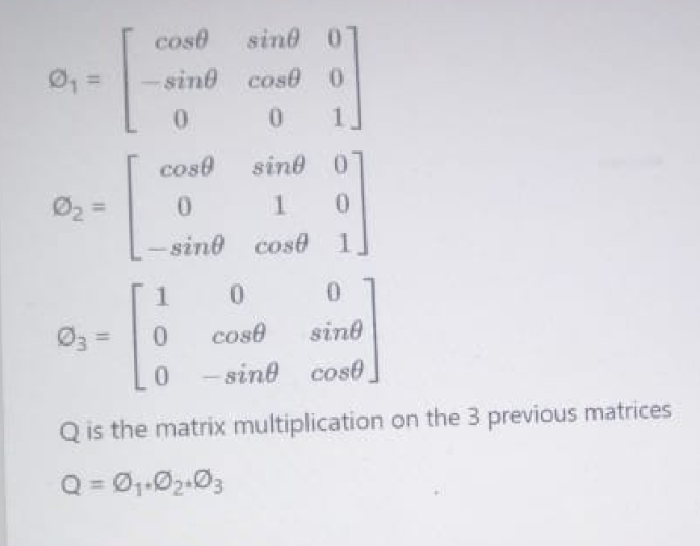

We did this matrix multiplications outside hardware then we’d apply the result on hardware.

After multiply this matrixes we get an equation from sin and cos for each element.

Inside hardware we calculate the equation for each element in only one cycle after reading the sin and cos for each theta.

**Q_matrix module**

We have many control i/o to control the functionality of the sub-module like start load finish read and done.

To load the sin and cos values from rot-CORDIC we set load signal and provide the number if iteration on addr bus.

After loading the 3 values of sin and the 3 values of cos we now rest load signal and set the start signal to start the calculations it takes one cycle.

Then we get done signal means it finishes the calculations then we reset start signal.

Then we can read the results any time by setting read signal the output matrix will be output as one element by clock cycle to reduce wires.